# Music Without Borders:

**System Requirements:**

1. PJSIP 1.12 library, built and installed
2. Python 2.7.2
3. Python Developer Tools
4. Gcc, binutils and Make
5. Python-MySQLdb package, built and install
6. MySQL

**To Start This Application:**

1. Open Terminal
2. $ cd (directory where the MWB files are)
3. $ python login.py

**User Help:**

**1.Login Window:**

When you start the application, you should see the following window

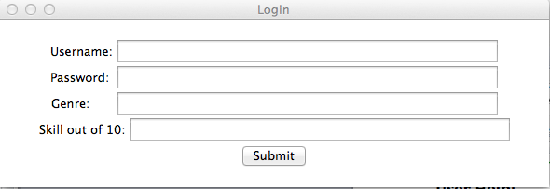

Here you need to enter your login credentials, if you don’t have an account then you need to go get one from IPTel (<http://www.iptel.org>). Genre helps us maintain the users in our database by the kind of music they play, ad Skill level out of 10, does the same but with skill as the differentiator.

We hope this helps the users find another users equal to their skill level and genre type.

**2. Main call window:**

Once you log in with proper credentials you should see the following window.

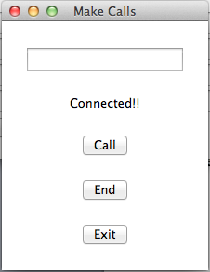

1 2

3 4

The text box lets you enter the address of the person you want to call. If you don’t know anyone don’t worry, you will also have a ‘Contacts’ window (see below) to show you all the people that are online right now with

*1* tells the current status of your call, turns to Phone Ringing when you are receiving a call.

*2* is the call button which also acts as the answer button when you are receiving a call.

*3* is the hangup button, which disconnects the calls.

*4* is the application’s exit button.

**3:Contacts Window**

This is what the contacts window looks like.

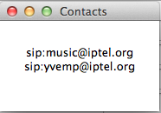

This window tells you SIP addresses of the people that are currently online and match your genre preference and skill level. You can call them at the addresses shown and start jamming.